Tim Mikkelsen

20 March 2024

Navigating Parenting Mistakes

This summary is from the Absolutely Magazine at avacadoposts.com. It is a very similar to the Connected Child book and its suggestions.

**Navigating Parenting Mistakes:**

**15 Symptoms and 8 Corrective Steps**

Parenting is no simple task—it requires a blend of love, patience, and the right strategies. But what happens when good intentions go awry? Unknowingly, even the most caring parents can slip into habits that hinder their child’s development. This article delves into the subtler signs of ineffective parenting—a topic often whispered about but seldom addressed head-on.

From recognizing these red flags to implementing transformative strategies, we will guide you through 15+ alarming symptoms of bad parenting and unveil 8 practical steps to correct them. Whether you’re a new parent feeling overwhelmed or a seasoned guardian seeking to refresh your approach, this comprehensive guide will empower you to foster a healthier, happier home environment. Join us as we explore how to turn parenting challenges into opportunities for growth and deeper connection with your children.

***–The Critical Signs Of Bad Parenting–***

**1. Not displaying adequate affection**

A lack of visible affection and emotional support can leave a child feeling disconnected and seeking attention through misbehavior. **Children often act out not because they want to be troublesome but because they crave an emotional bond with their parents.**

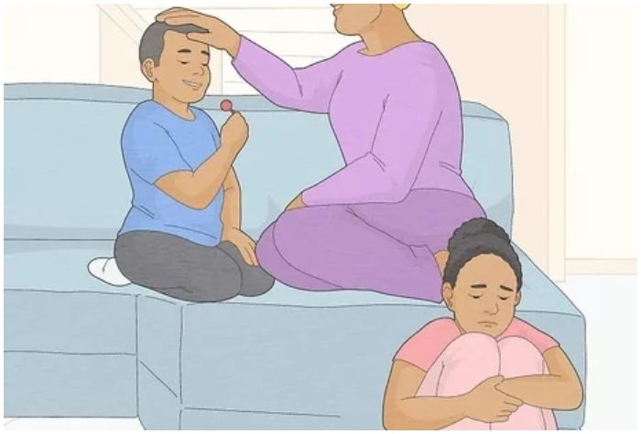

Showing love, warmth, and interest in your child’s is vital. S**mall gestures of affection and quality time spent together can significantly enhance your child’s sense of security and belonging.**

**2. You scold, punish and hit the child in front of everyone**

Disciplining a child is a sensitive aspect of parenting, but doing so publicly, in front of relatives or strangers, can have lasting negative effects. **This approach, mainly when it includes physical reprimands, embarrasses the child and hinders their self-esteem and trust in you.**

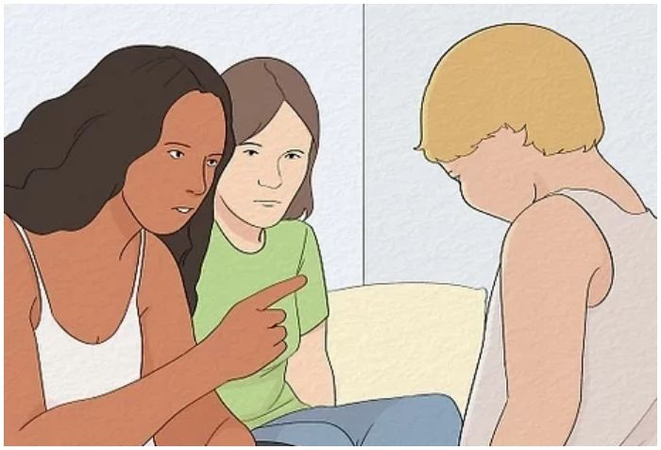

Children’s minds are impressionable; **they require understanding and a safe space to learn from their mistakes. It’s crucial to handle such situations with discretion and empathy.**

**3. More advice, less encouragement**

While advice is a necessary part of parenting, over-focusing on what a child should do rather than encouraging what they can do can be stifling. **Phrases like “You should wake up early for better grades” may seem constructive but can come across as critical.**

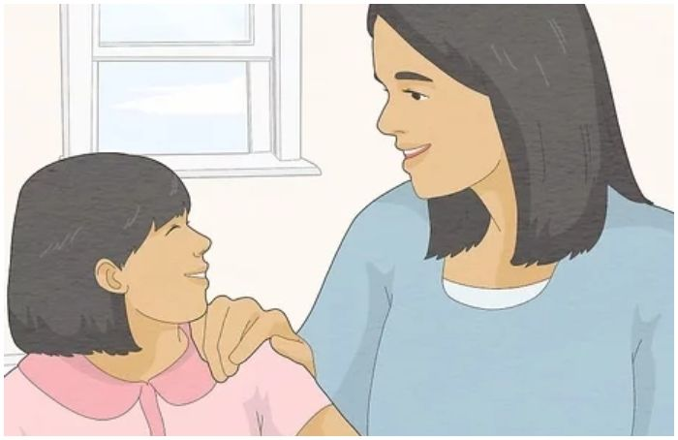

In contrast, encouragement like **“You’re intelligent and capable; let’s find a way to make early mornings more manageable for better grades”** fosters a positive and supportive environment. Balancing guidance with motivation is vital to cultivating a child’s self-confidence and independent thinking.

**16. Setting poor examples**

Children are like sponges, absorbing behaviors and habits from their surroundings, especially their parents.**If your child exhibits inappropriate behavior, it’s a moment to reflect on your own actions. Often, children mirror the conduct they observe at home.**

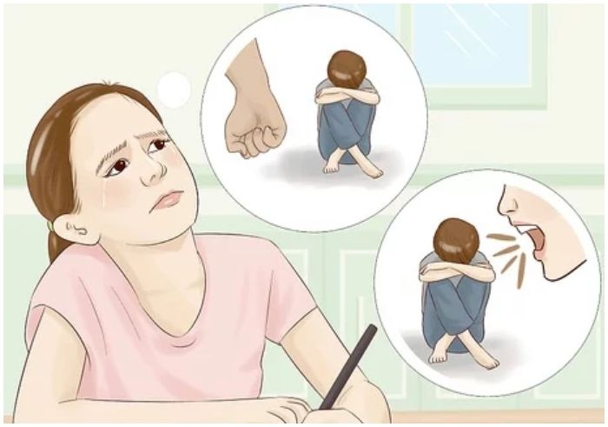

Parents must be mindful of their actions and set positive examples. **Good parenting involves teaching by example, as children are more likely to emulate what they see rather than what they are told.**

**17. The child is never offered a choice**

When parents make all decisions for their children, from academic choices to daily attire, it can lead to a lack of independence and autonomy in the child. **Children might feel constrained and rebel or act out by not offering them choices, sometimes even resorting to taking things without permission.**

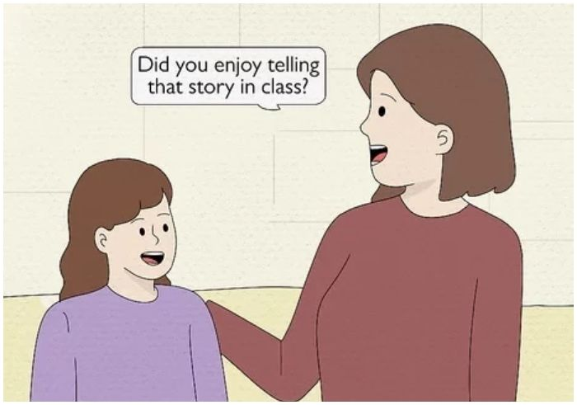

Encouraging decision-making skills by **giving them age-appropriate choices is important,** thereby promoting a sense of responsibility and self-confidence.

**18. Pampering to the point the child becomes arrogant**

**While showering your child with love and material comforts is natural, excessive pampering can lead to negative traits like arrogance and entitlement.** Overindulged children often struggle to appreciate the value of things and may take privileges for granted.

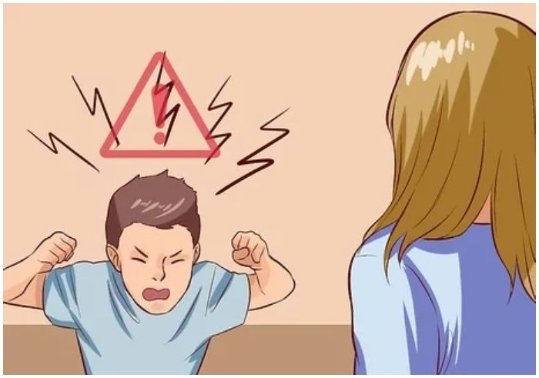

**It’s essential to balance affection with discipline, teaching them gratitude and empathy.** This approach helps in nurturing well-rounded individuals who respect themselves and others.

**19. Help solve even the smallest problems**

Helping your child is important, but constant interference in solving their problems, no matter how small, can hinder their development. **This overprotectiveness can lead to low self-confidence and poor problem-solving skills.**

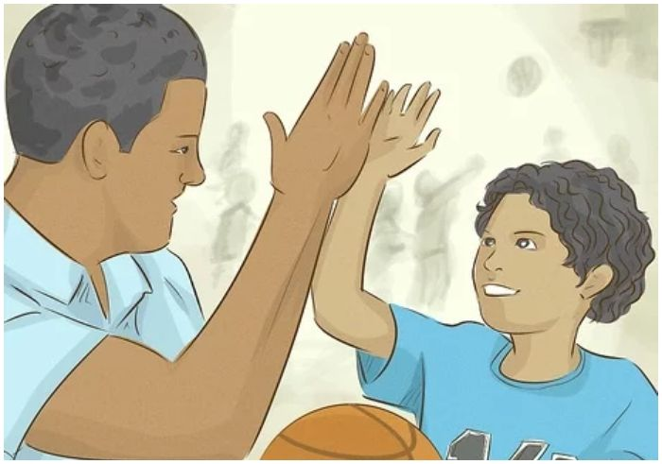

**Encouraging children to face challenges and find solutions independently, with guidance when necessary, fosters independence and resilience.** It’s about giving them the tools to handle situations, not handling every situation for them.

**20. Physically intimidate the child**

Using physical intimidation as a disciplinary method can have profound adverse effects on a child’s mental and physical well-being. **This approach instills fear rather than respect and can lead to long-term psychological issues.**

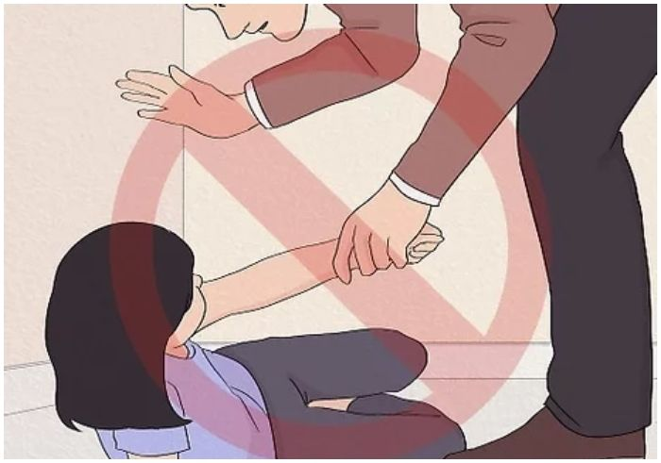

**It’s vital to employ positive discipline strategies focusing on teaching and guiding rather than controlling through fear.** Creating a safe and nurturing environment is key to healthy emotional and social development.

**21. Giving short, grumpy answers**

A child’s approach to a parent is often filled with curiosity and a desire for understanding. **When a parent consistently responds with short, grumpy answers, the child feels bewildered and deeply disappointed.** This behavior can create a barrier in communication, as the child might start to feel hesitant to approach their parent for guidance or support.

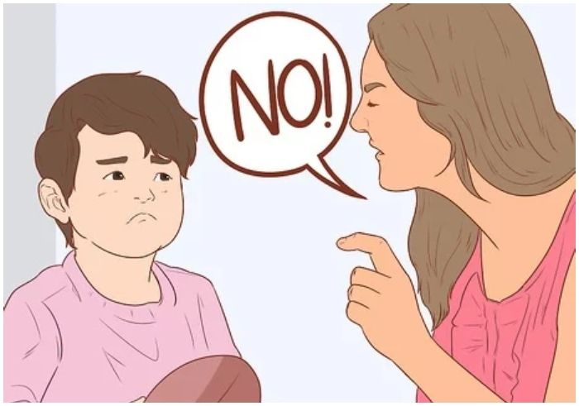

**Over time, this can lead to a breakdown in the parent-child relationship, as the child may seek understanding and comfort elsewhere.**It’s imperative for parents to be approachable and to communicate in a way that is nurturing, offering wisdom and comfort that the child seeks.

***—8 Practical Solutions: How To Be A Better Parent–***

**1. Have hands-on involvement in parenting**

Effective parenting goes beyond just providing for a child’s physical needs; it involves emotional engagement and teaching valuable life lessons. **Strive to build a relationship that balances control and love, ensuring a nurturing environment for the child’s well-being.**

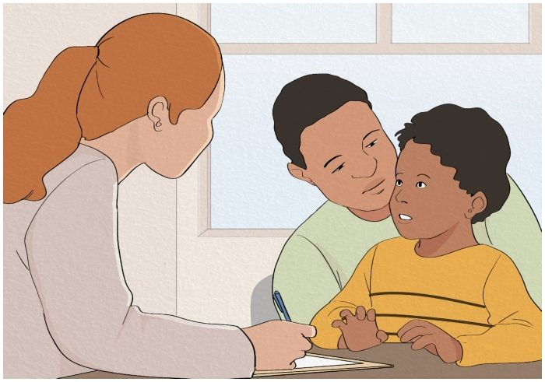

**Being actively involved in your child’s life, understanding their needs,** and guiding them through life’s challenges are critical aspects of hands-on parenting.

**2. Look To Improve Yourself First**

Reflecting on our parenting is crucial, especially when addressing our children’s behavior. **Children often mirror the environment and influence around them, including their parents’ actions and attitudes.**Recognizing this, it’s important for us as **parents to self-assess for any negative behaviors or patterns we might inadvertently be passing on.**

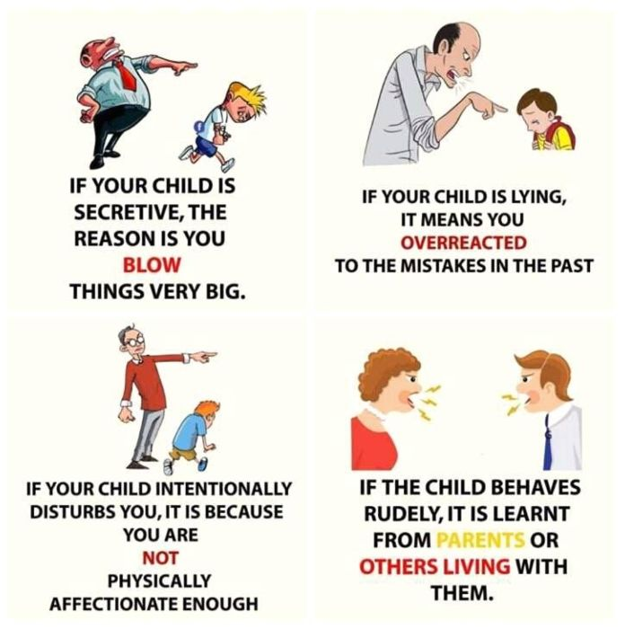

Are we displaying aggression, impatience, or neglect? **Do we communicate effectively and with empathy? Acknowledging these traits in ourselves and actively working to improve them can significantly impact our children’s behavior.** Remember, effective parenting involves continuous learning and self-improvement, shaping a healthier environment for our children’s growth and development.

**3. Refrain from yelling and striking the child**

Dealing with children’s misbehavior can be challenging, and it’s easy to lose patience and resort to yelling or physical discipline. **However, these actions can be harmful and leave lasting negative impressions on the child.**

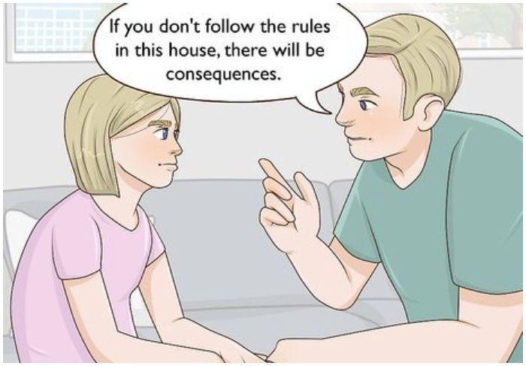

Instead, aim for more constructive methods of discipline. **For example, if a child breaks a sibling’s toy, explain the consequences of such actions, like taking away a favorite toy, until they apologize and understand why their behavior was wrong.** This approach teaches responsibility and empathy without resorting to fear or aggression.

**4. Give reasons for your instructions**

Children are naturally curious and often do not understand the rationale behind specific instructions. **Simply commanding a child to follow rules without explanation, like “Sleep on time,” can lead to resistance.**

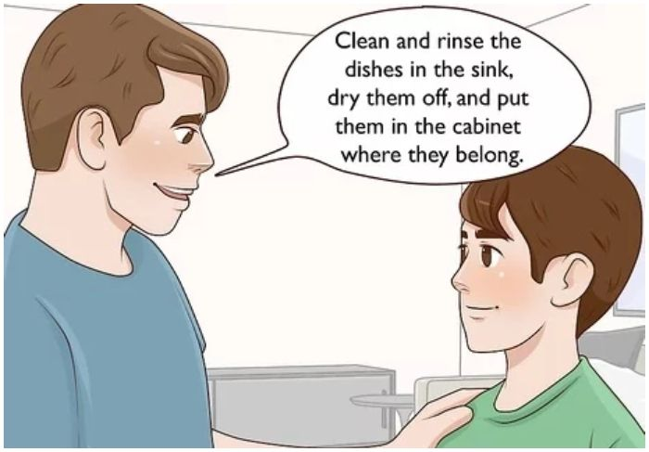

**Parents need to communicate the reasons behind their rules in a way that children can understand.** This helps the child grasp the importance of the instruction and fosters a sense of respect and understanding between the parent and child.

**5. Set rules after discussion**

Engaging your child in the process of setting new rules is a crucial aspect of effective parenting. **This involves having a discussion with your child before implementing any new guidelines.** Involving them in decision-making **makes them feel valued and boosts their self-esteem.**



It also encourages them to take ownership of their actions and think twice before violating the rules. **Such discussions help foster a sense of responsibility and mutual respect between parent and child.**

**6. Let the child have some choice**

Giving your child a say in decisions that affect them, especially during adolescence, is important for their development. **Asking for their opinion, rather than unilaterally deciding for them, can prevent feelings of irritation and helplessness.**



**For instance, discussing changes in their tuition or other activities and asking for their input can effectively teach decision-making skills.** This approach involves them in important choices and introduces the concept of responsibility.

**7. Listen when he says something**

Listening attentively to your child, whether sharing mundane details of their day or achievements, is integral to good parenting. **Dismissing their stories or postponing the conversation can be disheartening for a child. It’s important to show them that their thoughts and feelings are valued.**

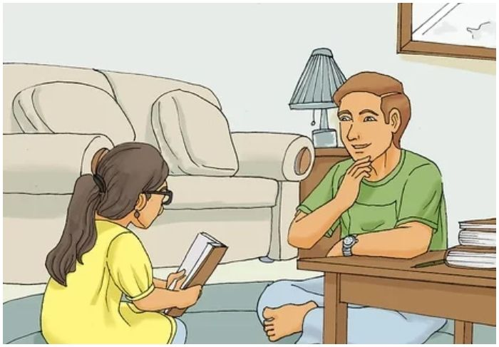

You’re fostering a trusting and open relationship by listening and responding with interest. **Additionally, appreciating honesty and truthfulness in your child encourages these virtues.**

**8. Set good examples**

Leading by example is one of the most effective ways to teach children. **When parents practice what they preach, children are likelier to follow suit.** Demonstrating positive behavior, such as healthy habits, honesty, and empathy, sets a powerful example for children to emulate.

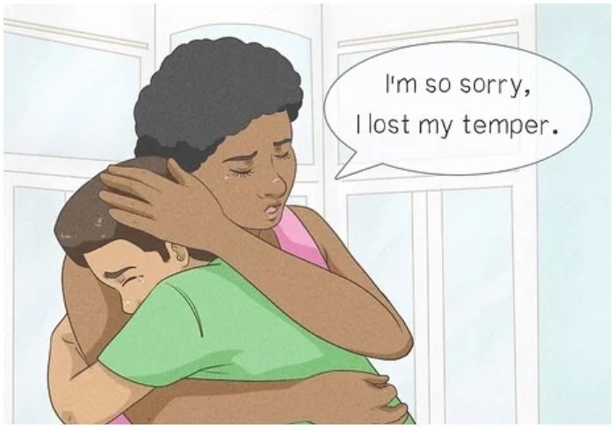

This approach is much more effective than mere verbal instructions, as children tend to model their behavior on what they see in their parents. **Thus, being a role model in action and values is essential for shaping the character and habits of your child.**